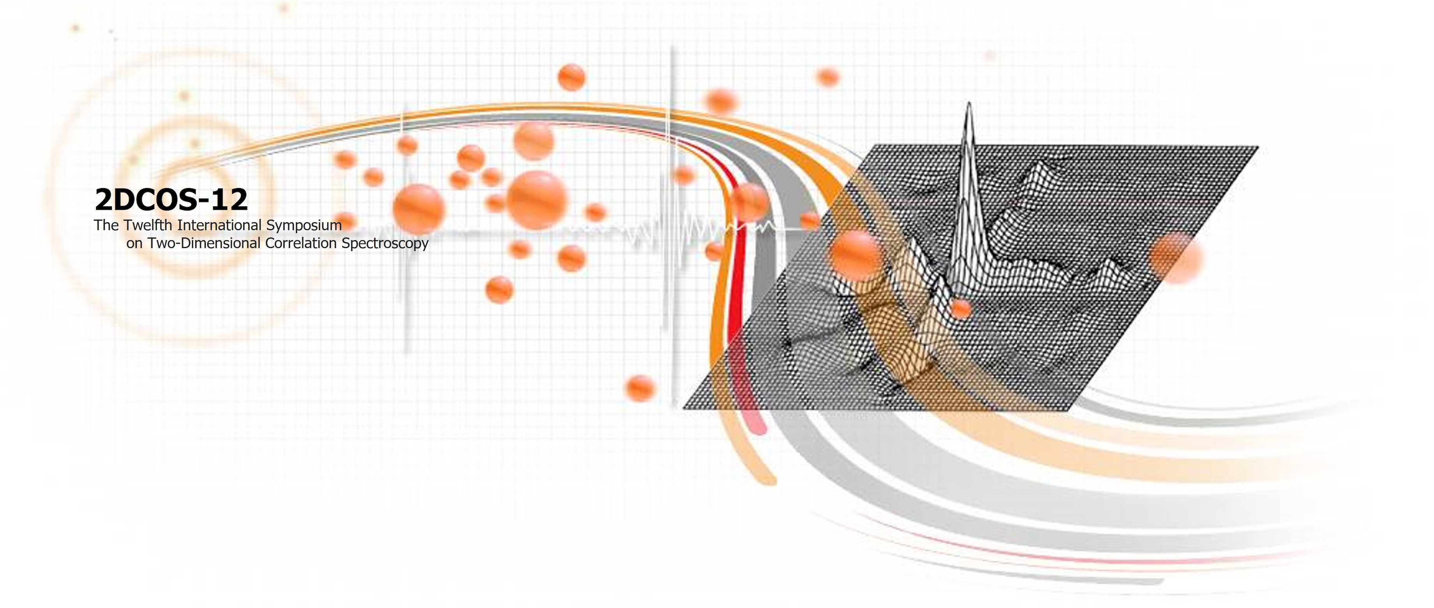

**2DCOS-XII REGISTRATION**

**DELEGATE DETAILS**

Professional Title (Prof., Dr., etc.,) :

First Name: Last Name:

Student: YES NO *(please delete as appropriate)*

Organization:

Address:

Phone: Fax: (including international code)

Email:

**\*Registration fee for all participants is waived.**

********************************************************************************

**SEND COMPLETED FORMS TO:**

Prof. Young Mee Jung, General Chair of 2DCOS-XII,

Department of Chemistry, Kangwon National University, Chuncheon 24341, Korea

**E-mail:** [**ymjung@kangwon.ac.kr**](mailto:ymjung@kangwon.ac.kr) **FAX: +82-33-259-5667**